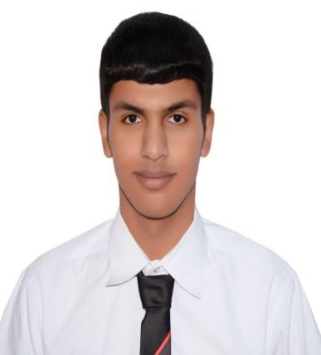Hussain Ali

[Bahraini] • [990910075] • [33332283] • [Single] [[hussain99alsuwaidi@gmail.com]](mailto:[Alsuwaidisara96@gmail.com])

[House 649 , Road 1409 , Block 1214 , Hamad Town]

**Career Objective**

I can work independently using my own initiative or as a part of a team.

**Experience**

* The Bahrain Petroleum Cpmpany ( 4 Oct 2016 to 3 Nov 2016 )

**Education**

**2014 – 2017**  Jidhafs Secondary Technical School ( Mechanics of cars )

**Skills**

Computer Skills:

* Microsoft Office

Interpersonal skills:

* Quick learner
* Teamwork
* Able to work under pressure

**Hobbies and interests**

Reading

Riding a horse

**Languages**

English

Arabic